**Kurtosis and Skewness**

**Overall Analysis Report for Kurtosis and Skewness:**

* The **skewness** and **kurtosis** values provide important insights into the shape and distribution of the data. Here's an analysis of these two statistical measures based on the data provided for each column:

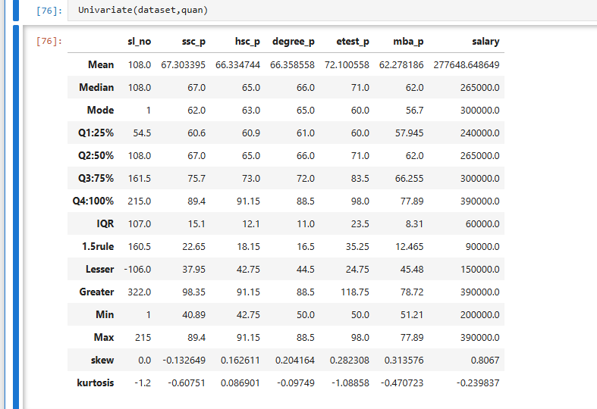

**1. Skewness Analysis:**

* **Skewness** is a measure of the asymmetry of the probability distribution of a real-valued random variable. It indicates whether the data is skewed to the left (negative skew) or to the right (positive skew). A skewness of 0 indicates a perfectly symmetrical distribution.

**General Interpretation:**

* Most of the variables (ssc_p, hsc_p, degree_p, etest_p, mba_p, salary) show either no skew or mild positive skew.
* **ssc_p** is the only column that is perfectly symmetrical (skew = 0.0), while the rest of the columns exhibit slight positive or negative skewness.

**2. Kurtosis Analysis:**

* **Kurtosis** is a statistical measure used to describe the distribution's tails and the sharpness of its peak.
  + A **positive kurtosis** indicates a distribution with heavier tails and a sharper peak.
  + A **negative kurtosis** indicates a distribution with lighter tails and a flatter peak.
  + A kurtosis value of **3** indicates a normal distribution (Mesokurtic).
  + Values above 3 indicate a distribution with heavier tails (Leptokurtic), while values below 3 indicate lighter tails (Platykurtic).

**General Interpretation:**

* All columns show **negative kurtosis**, which means their distributions have **lighter tails and flatter peaks** compared to a normal distribution. This suggests the data is not heavily concentrated around the mean, and the extreme values (outliers) are less frequent.

**Summary:**

* **Skewness**: Most of the columns exhibit **mild positive skew** (except ssc_p, which is perfectly symmetric). This suggests that, for most variables, the distribution has a longer right tail, with a few higher values stretching out the distribution.
* **Kurtosis**: All columns show **negative kurtosis**, indicating **platykurtic distributions** with **lighter tails and flatter peaks** compared to a normal distribution. There is less concentration of data at the extremes, and outliers are less common.

In general, the data for the variables appears relatively symmetrical and not prone to extreme outliers, although certain variables like salary may still have slightly heavier right tails.